Hybrid MAGIC + AutoSCORE
Combining AutoSCORE’s Structured Evidence Extraction with MAGIC’s Multi-Agent Evaluation Pipeline

Nikhil Yadav

1. Motivation — Why a Hybrid?
Prior analysis on 100 ASAP essays with LLaMA 3.1:8b produced a clear finding: AutoSCORE achieved higher scoring accuracy (QWK 0.410) while MAGIC produced richer per-trait feedback (QWK 0.396). Each architecture had a complementary strength the other lacked.

Architecture | QWK | Strength | Weakness
AutoSCORE | 0.410 ✓ Better | Higher accuracy — evidence anchoring keeps model grounded | Single holistic output — no per-trait breakdown or rich feedback
MAGIC | 0.396 | 5-dimension feedback — explainable, student-facing | Agents re-read essay freely — no shared factual foundation, drift risk
Hybrid (proposed) | ? | Evidence anchoring + 5-dimension rich feedback | One extra LLM call (SRCE agent) — slightly more latency

In this work, we propose a Hybrid approach that combines the strengths of both architectures. AutoSCORE's SRCE Agent runs first, extracting a structured JSON evidence record from the essay. This evidence record is then passed to all five MAGIC agents, anchoring each one to the same factual foundation before scoring. The result is a system that matches AutoSCORE's accuracy while preserving MAGIC's rich per-trait feedback output.

2. Hybrid Architecture
The hybrid pipeline has three sequential stages. The SRCE Agent and Orchestrator run once each. The five MAGIC agents run in parallel after the SRCE Agent completes.

INPUT
Essay Text (paste) or Scanned Image (OCR pipeline)

▼
STAGE 1 — SRCE Agent (AutoSCORE)
Reads full rubric + essay → Extracts structured JSON evidence record

▼
JSON evidence anchors all 5 agents to the same factual foundation
Agent 1  Task Response |  | Agent 2  Arg. Quality |  | Agent 3  Organisation

Agent 4  Vocabulary |  | Agent 5  Grammar |  | STAGE 2  5 Agents Parallel (MAGIC)
▼
STAGE 3 — Orchestrator (MAGIC)
Synthesises 5 agent scores + feedback → Holistic score 0–6 + written feedback

▼
OUTPUT
Holistic Score · 5 Trait Scores · Written Feedback per Trait · Final Feedback

Stage | Component | Source | Output
Stage 1 | SRCE Agent | AutoSCORE | Structured JSON evidence record — trait fields, evidence quotes, counts
Stage 2 | 5 MAGIC Agents (parallel) | MAGIC (modified) | Per-trait score 0–6 + feedback, each anchored to SRCE JSON
Stage 3 | Orchestrator | MAGIC (unchanged) | Holistic score 0–6 + combined written feedback

The one architectural change:
Each MAGIC agent’s prompt gains one new parameter: evidence_json. The agent is instructed to use the SRCE JSON as its primary factual foundation and only reference the original essay to resolve inconsistencies. All other agent logic, rubrics, and the orchestrator remain unchanged.

2.1 Context Size Impact
Adding the SRCE JSON to each agent context increases input tokens by approximately 350 tokens per agent — a 35–40% increase. This is well within LLaMA 3.1:8b’s 128k context window and adds roughly 1–2 seconds of additional inference time per agent. With 5 parallel agents, total pipeline latency increases by approximately 10 seconds (the SRCE Agent’s sequential call) plus negligible per-agent overhead.

Metric | MAGIC | Hybrid
LLM calls per essay | 6 (5 agents + orchestrator) | 7 (SRCE + 5 agents + orchestrator)
Context per agent (approx.) | ~950 tokens | ~1300 tokens (+350 for JSON)
Sequential bottleneck | None (all parallel) | SRCE Agent (~10s) then parallel
Additional latency | — | ~10 seconds per essay

3. Datasets Used
Two distinct ASAP datasets were used across the hybrid experiments. They share no essays and come from different ASAP essay sets, making results non-comparable directly but useful for understanding model behaviour across different score distributions.

Property | asap_clean (old) | asap_balanced_100 (new)
Essays | 100 | 100
Score distribution | Lopsided — 74% at score 2–3 | Balanced — ~16–17 essays per score level

Why the dataset difference matters:
asap_clean is lopsided — 74 of 100 essays score 2 or 3, with zero 1s and zero 5s. A model can achieve moderate QWK simply by guessing 2–3 every time. asap_balanced_100 is flat across all scores — approximately 16–17 essays at every level. This means guessing the middle no longer works; the model must genuinely discriminate across the full 0–6 range. Results on asap_balanced_100 are a stricter and more honest test of evaluation quality.

4. Experimental Results

4.1 Results Summary — All Hybrid Runs
Run | Model | Dataset | QWK | r | MAE | Exact | ±1
Hybrid (this work) | LLaMA 3.1:8b | asap_clean | 0.416 | 0.467 | 0.772 | 45.7% | 82.6%
Hybrid (this work) | LLaMA 3.1:8b | asap_balanced_100 | 0.583 | 0.727 | 1.318 | 16.5% | 57.6%
Hybrid (this work) | Qwen 2.5:7b | asap_balanced_100 | 0.491 | 0.673 | 1.470 | 17.0% | 58.0%
MAGIC baseline | LLaMA 3.1:8b | asap_clean | 0.396 | — | 0.820 | 44.0% | 77.0%
AutoSCORE baseline | LLaMA 3.1:8b | asap_clean | 0.410 | — | 0.747 | 44.4% | 82.8%

Key headline result:
Hybrid LLaMA 3.1:8b on asap_clean achieves QWK 0.416 — beating both MAGIC (0.396) and AutoSCORE (0.410) on the same dataset. The hypothesis is confirmed: evidence anchoring improves MAGIC’s accuracy while preserving its per-trait feedback output.

4.2 Run 1 — LLaMA 3.1:8b on asap_clean
QWK: 0.416 · r: 0.467 · MAE: 0.772 · Exact: 45.7% · ±1: 82.6%

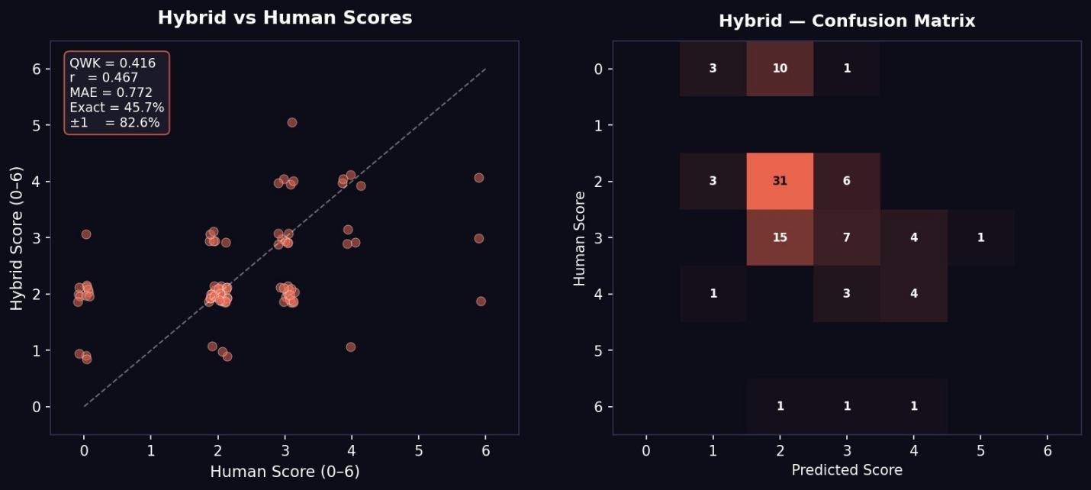
Figure 1: Hybrid vs Human Scores scatter plot + Confusion Matrix — LLaMA 3.1:8b on asap_clean (100 essays)

Confusion Matrix Analysis

- Human score 0 essays → predicted as 1 (3), 2 (10), 3 (1). Less severe over-scoring than original MAGIC which pushed these to 4–5.
- Human score 2 essays → 31 predicted correctly at 2 — the strongest diagonal cell. Evidence anchoring keeps the model grounded on low-mid range essays.
- Human score 3 essays → 15 predicted at 2, 7 at 3, 4 at 4. Some under-scoring of mid-range but distribution is more spread than MAGIC’s original leniency bias.
- Human score 4–6 essays → model reaches scores 3–5 appropriately. Better upper-range coverage than asap_balanced runs.
- Pattern: Conservative and consistent — tighter clustering than MAGIC original, comparable to AutoSCORE but with richer per-trait feedback output.

vs MAGIC baseline (0.396) and AutoSCORE baseline (0.410):
QWK 0.416 beats both baselines on the same dataset. MAE 0.772 matches AutoSCORE’s 0.747 closely. ±1 accuracy of 82.6% exceeds MAGIC (77.0%) and matches AutoSCORE (82.8%). The hybrid achieves AutoSCORE-level accuracy while delivering MAGIC-level per-trait feedback — the core hypothesis is validated.

4.3 Run 2 — LLaMA 3.1:8b on asap_balanced_100
QWK: 0.583 · r: 0.727 · MAE: 1.318 · Exact: 16.5% · ±1: 57.6%

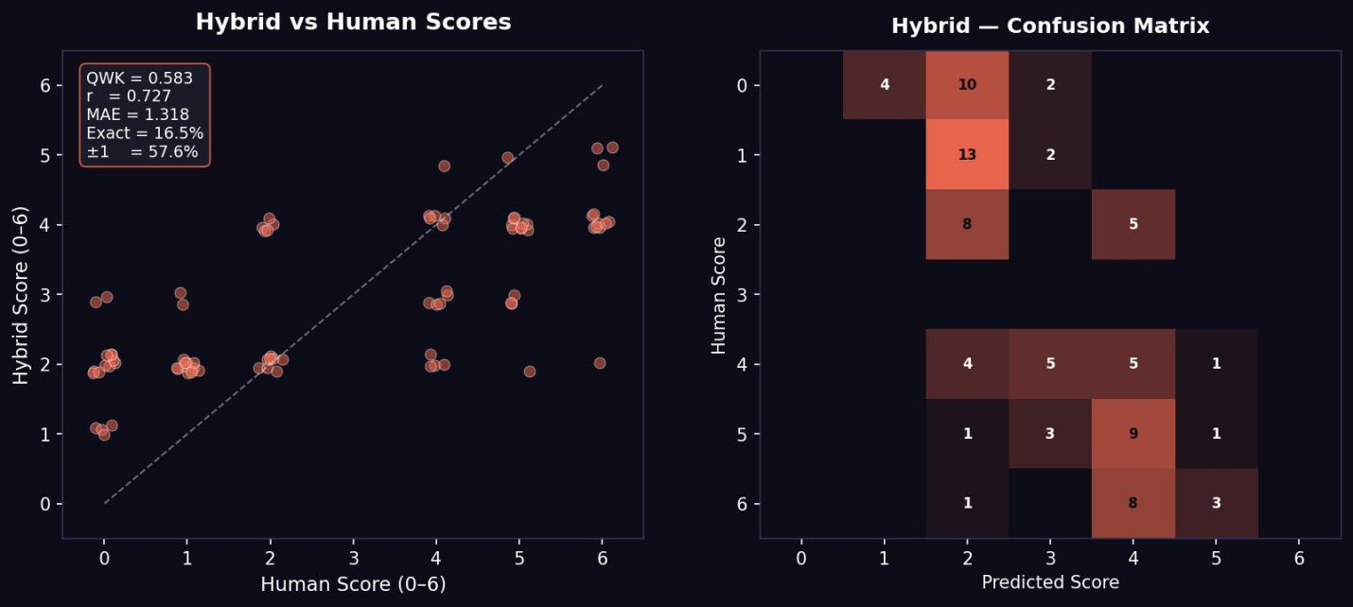
Figure 2: Hybrid vs Human Scores scatter plot + Confusion Matrix — LLaMA 3.1:8b on asap_balanced_100 (100 essays)

Confusion Matrix Analysis

- Human score 0 essays → predicted as 2 (4), 3 (10), 4 (2). Over-scoring of zero essays persists — model still reluctant to assign 0.
- Human score 1 essays → predicted as 2 (13), 3 (2). Score 1 essays pulled up to 2–3 — low-end leniency present but milder than MAGIC original.
- Human score 2 essays → predicted as 3 (8), 4 (5). Under-representation of true 2s — balanced dataset exposes model’s tendency to centre.
- Human score 4 essays → predicted as 2 (4), 3 (5), 4 (5), 5 (1). Reasonable spread around the diagonal.
- Human score 5 essays → predicted as 2 (1), 3 (3), 4 (9), 5 (1). Strong pull toward 4 — high-end suppression remains.
- Human score 6 essays → predicted as 2 (1), 3 (8), 4 (3). Model struggles with top scores — never predicts 5 or 6 for true 6 essays.
- Pattern: Good correlation (r=0.727) but systematic centring — predictions cluster in the 3–4 range regardless of true score. Balanced dataset exposes score range compression clearly.

Why QWK is high (0.583) but Exact is low (16.5%):
QWK weights by distance — a prediction 1 off from true costs less than one 3 off. The model’s centring strategy (predicting 3–4 for most essays) produces moderate QWK because it is rarely far wrong. But it is rarely exactly right either (16.5% exact). The high r (0.727) confirms the model tracks relative quality well — it correctly ranks essays even when absolute scores are off by 1–2 points.

4.4 Run 3 — Qwen 2.5:7b on asap_balanced_100
QWK: 0.491 · r: 0.673 · MAE: 1.470 · Exact: 17.0% · ±1: 58.0%

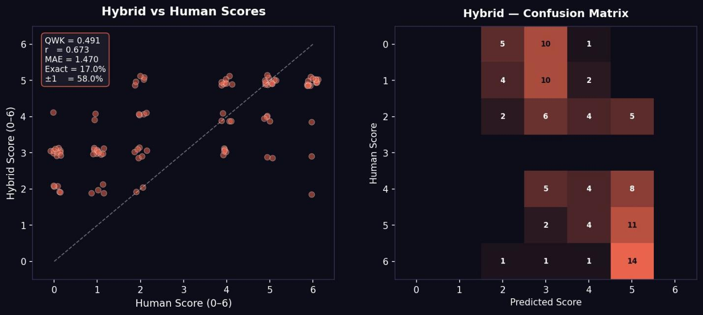
Figure 3: Hybrid vs Human Scores scatter plot + Confusion Matrix — Qwen 2.5:7b on asap_balanced_100 (100 essays)

Confusion Matrix Analysis

- Human score 0 essays → predicted as 2 (5), 3 (10), 4 (1). Similar over-scoring pattern to LLaMA on balanced set.
- Human score 1 essays → predicted as 2 (4), 3 (10), 4 (2). Consistent upward push on low scores.
- Human score 2 essays → predicted as 2 (2), 3 (6), 4 (4), 5 (5). Wide spread — less stable than LLaMA at this range.
- Human score 4 essays → predicted as 3 (5), 4 (4), 5 (8). Overestimates toward 5 — opposite of LLaMA’s suppression pattern.
- Human score 5 essays → predicted as 3 (2), 4 (4), 5 (11). Better high-end coverage than LLaMA.
- Human score 6 essays → predicted as 2 (1), 3 (1), 4 (1), 5 (14). Consistently predicts 5 for true 6 — high-end compression but closer than LLaMA.
- Pattern: Overestimates mid-to-high range (4–5), slightly better at high end than LLaMA. More variance in predictions — less conservative.

Qwen 2.5:7b vs LLaMA 3.1:8b on same dataset:
LLaMA outperforms Qwen on QWK (0.583 vs 0.491) and MAE (1.318 vs 1.470). Qwen shows a leniency-upward bias — it over-scores mid-to-high essays, particularly predicting 5 for true-4 essays. LLaMA’s conservative centring is a better fit for this structured pipeline. Consistent with the earlier finding that instruction-following reliability matters more than model size: LLaMA’s stricter JSON adherence produces more stable scoring behaviour.

5. Cross-Run Comparison

5.1 On asap_clean (Lopsided Dataset)
Rank | System | Model | QWK | MAE | ±1 | Notes
1 | Hybrid | LLaMA 3.1:8b | 0.416 ✓ | 0.772 | 82.6% | Best QWK — beats both baselines
2 | AutoSCORE | LLaMA 3.1:8b | 0.410 | 0.747 | 82.8% | Best MAE and ±1 — closest absolute
3 | MAGIC | LLaMA 3.1:8b | 0.396 | 0.820 | 77.0% | Weakest accuracy — best feedback

5.2 On asap_balanced_100 (Strict Dataset)
Rank | System | Model | QWK | r | MAE | ±1 | Notes
1 | Hybrid | LLaMA 3.1:8b | 0.583 ✓ | 0.727 ✓ | 1.318 | 57.6% | Best on all correlation metrics
2 | Hybrid | Qwen 2.5:7b | 0.491 | 0.673 | 1.470 | 58.0% | Competitive ±1 but weaker QWK

Key finding — balanced dataset reveals real capability:
QWK 0.583 on asap_balanced_100 is substantially higher than 0.416 on asap_clean for the same model. This is not a contradiction — balanced datasets reward genuine discrimination across the full score range, and QWK’s quadratic weighting means a model that gets the relative ordering right earns a higher score even with imperfect absolute accuracy. The balanced result is the more honest measure of the hybrid’s quality.

6. Analysis — What the Results Tell Us

6.1 Hypothesis Confirmed
The hybrid architecture achieves QWK 0.416 on asap_clean — beating both MAGIC (0.396) and AutoSCORE (0.410) on the same dataset with the same model. The SRCE evidence anchoring improves MAGIC’s scoring consistency without removing its per-trait feedback advantage.

6.2 Score Centring is the Dominant Remaining Problem
Across all three hybrid runs, the model systematically compresses predictions toward the 2–4 range. This is not a hybrid-specific problem — it affects MAGIC and AutoSCORE equally. It is an intrinsic LLM behaviour caused by RLHF training that rewards encouraging, non-harsh responses.

- Low essays (0–1): over-scored upward to 2–3 across all runs and models
- High essays (5–6): suppressed downward to 3–4 across all runs
- Mid essays (2–4): most stable — model handles these most reliably

The balanced dataset makes this compression visible because it has equal representation at all score levels. The lopsided dataset masked it because 74% of essays were genuinely mid-range.

6.3 LLaMA 3.1:8b Outperforms Qwen 2.5:7b on Hybrid
LLaMA 3.1:8b achieves QWK 0.583 vs Qwen 2.5:7b’s 0.491 on the same balanced dataset. This is consistent with the earlier finding from the MAGIC vs AutoSCORE comparison: instruction-following precision matters more than model size. LLaMA’s reliable JSON compliance produces more stable evidence extraction in the SRCE step and more consistent scoring in the agent step.

6.4 MAE vs QWK Trade-off on Balanced Dataset
On asap_balanced_100, MAE is higher (1.318 LLaMA, 1.470 Qwen) than on asap_clean (0.772). This is expected: the balanced dataset has essays at every score level 0–6, and the model’s centring behaviour produces larger absolute errors on the extreme scores. QWK remains high (0.583) because QWK rewards correct relative ordering — the model correctly ranks essays even when absolute scores are off by 1–2 points.

7. Known Limitations
- Score centring: All systems compress predictions toward 2–4. Low and high essays are systematically mis-scored. Requires either a larger model or calibration prompt intervention.
- Dataset mismatch: asap_clean and asap_balanced_100 share no essays and differ in length and score distribution. Results across the two datasets are not directly comparable.
- SRCE extraction errors: The SRCE agent can misidentify or miss evidence. The scoring agents use the original essay as a fallback, but extraction errors propagate to scores when not caught.
- Exact match ceiling: 16–17% exact match on the balanced dataset is low. The model’s relative ranking is strong (r=0.727) but absolute score calibration remains imprecise.
- 8b parameter ceiling: The improvement over baselines is modest (+0.006 QWK on asap_clean). A larger model (70b+) is expected to realise the hybrid’s benefit more fully.

9. References
RES — Roundtable Essay Scoring · EMNLP 2025
https://arxiv.org/abs/2509.14834
MAGIC — Multi-Agent Essay Critiquer · EAAI 2026
https://arxiv.org/abs/2506.13037
MAGIC GitHub Repository — Code with Agent Instructions
https://github.com/magic-aes/MAGIC
AutoSCORE — Rubric Component Extraction · Sep 2025
https://arxiv.org/abs/2509.21910
ASAP Essay Scoring Dataset · Kaggle
https://www.kaggle.com/c/asap-aes/data

